HOME AUTOMATION:

A project on Home Automation and home security System that can be controlled via smart phones.

Home automation system which is a complete relief for the user who wishes to get up at a desired time.

The user will be asked to set an alarm, adding the task. All the arrangements including turning on of the lights, alarm buzzing, task notifications and coffee maker are set up automatically without the users intervention.

A Universal App is created which allows you to put timestamps on database, along with the choice of switching on of the lights and coffee maker.

This app is in the form of a calendar in which different events could be entered with a date and time according to which it will update the sensors so that a task could be performed.

Basically we are looking to connect everyday devices and make them interact with one another in a way that will make our lives easier and more technology driven and make for a smart home.

ARCHITECTURE

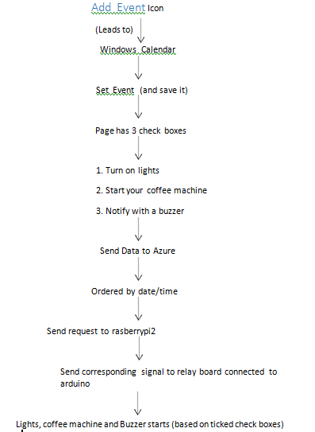

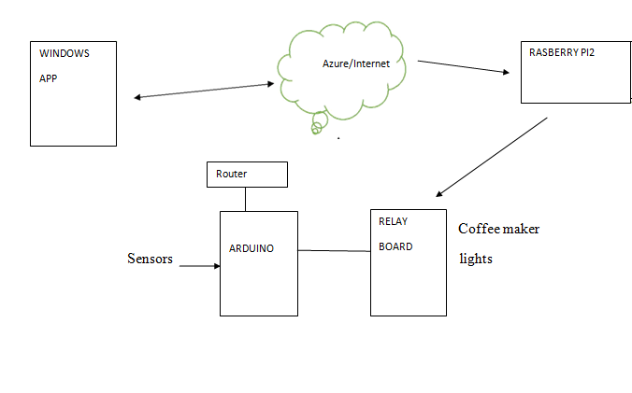

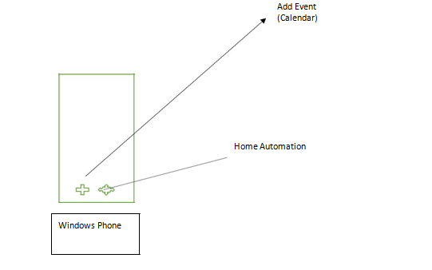

Snapshots of the windows app

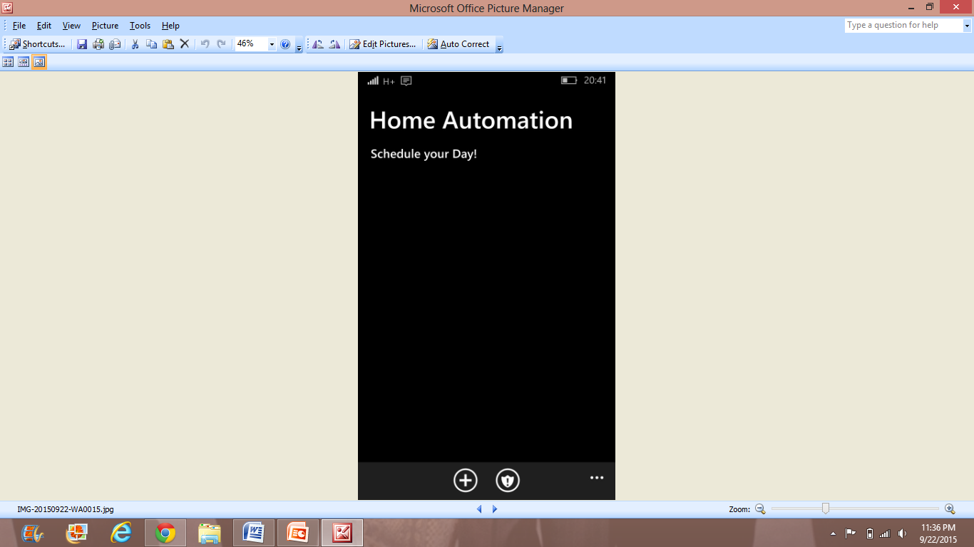

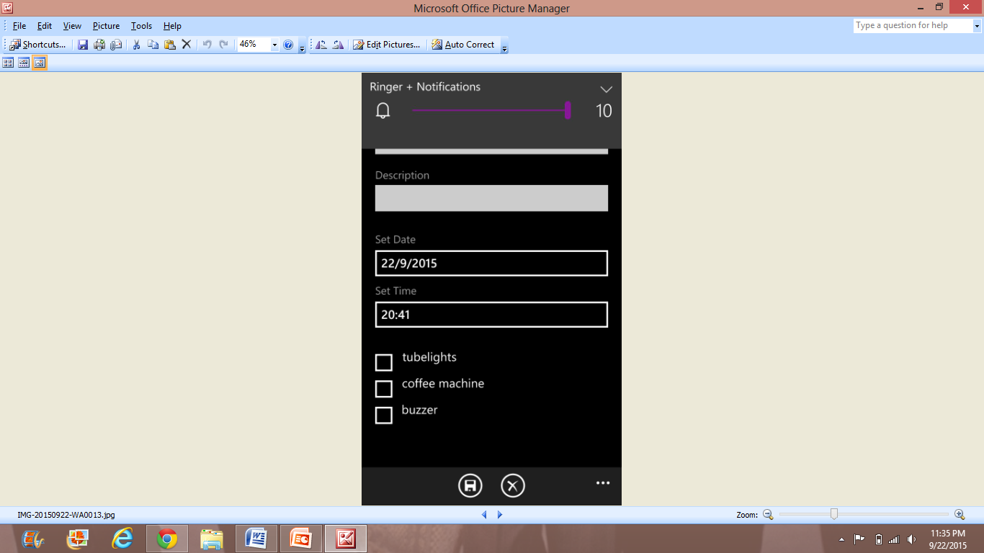

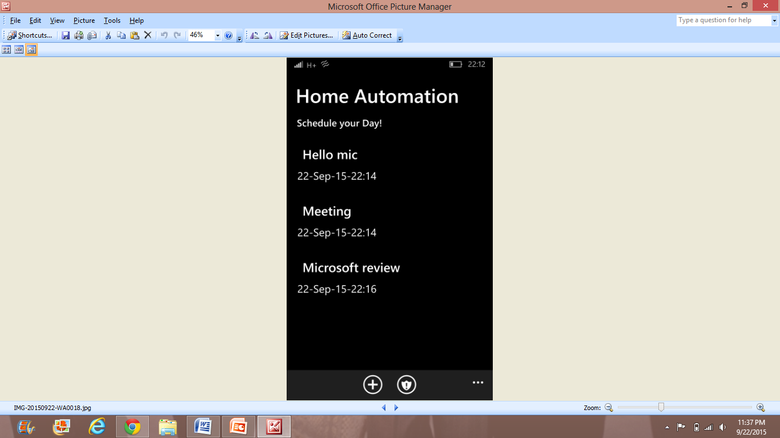

Home Security:

Openhab is a software for integrating different home automation systems and technologies into one single solution.

Openhab is connected to various sensors by means of Mqtt,which is a machine-to-machine (M2M)/"Internet of Things" connectivity protocol.

Elements that are focus of the design:

Features unique to the project:

* Cheap - each sensor node is easily available at a very affordable price.
* Attractive and secure user interface - the OpenHAB UI is available as a mobile app but is also accessible through any web browser and the communication between the display device and the Raspberry Pi is done using encryption and authentication. So your home automation system stays private. It's also pretty easy to use considering the sophistication and features.
* Controls commercial products: If you happen to have Sonos speakers, Insteon lights/plugs, or z-wave at home, you can control these devices too.
* Allows you to integrate any sensor to your automation needs.

List of sensors used:

* Temperature / Humidity:
* Motion Sensor:
* Smoke / Gas:
* Light Sensor:
* Water sensor:
* Light sensor:

Architecture:

**RASBERRYPI2 WITH OPENHAB+MOSQUITTO**

**ARDUINO FIELD NODE**

**ARDUINO ETHERNET GATEWAY**

**APP UI**

Purpose of each sensor:

**1. Temperature / Humidity:**

Displays the temperature and humidity on the smart phone interface.

User can access the app and check the temperature and humidity in the house at any time.

2.Motion Sensor:

* Used as a security sensor to notify you when movement is detected.
* monitors a room and sets notification when it senses a moving body.
* If used in the laundry room, it will notify if the washer/dryer is still running without having to go to the room.

3. Smoke / Gas:

Used to send a notification to you when the sensor senses smoke, fire, or LP gas .

4. Water sensor:

**Water Detection** circuit senses if there is a water leak or overflow in the room and notifies accordingly.

5. sound sensor:

* This circuit will check if there is any loud noise while the owner is away from home.

If any large sound is noticed, it is seen on the app.

* In the laundry room, if determines when washer or dryer cycle starts and completes.

6. [Light Sensor](http://www.instructables.com/id/Uber-Home-Automation/step9/)  
Detect whether the light got left on or not. Displays the status of light on the smart phone app.

windows app :

Azure is used to achieve two things:

1. For receiving data from Universal App, processing it and sending the corresponding signals to Raspberry pi2.
2. For collecting the readings of the sensors in a continuous manner and sending the same to the app in the form of pop-ups or notifications.

These two things were achieved using the Service Bus, Azure Database, Stream Analytics and Event Hubs feature of Azure.